Mobility
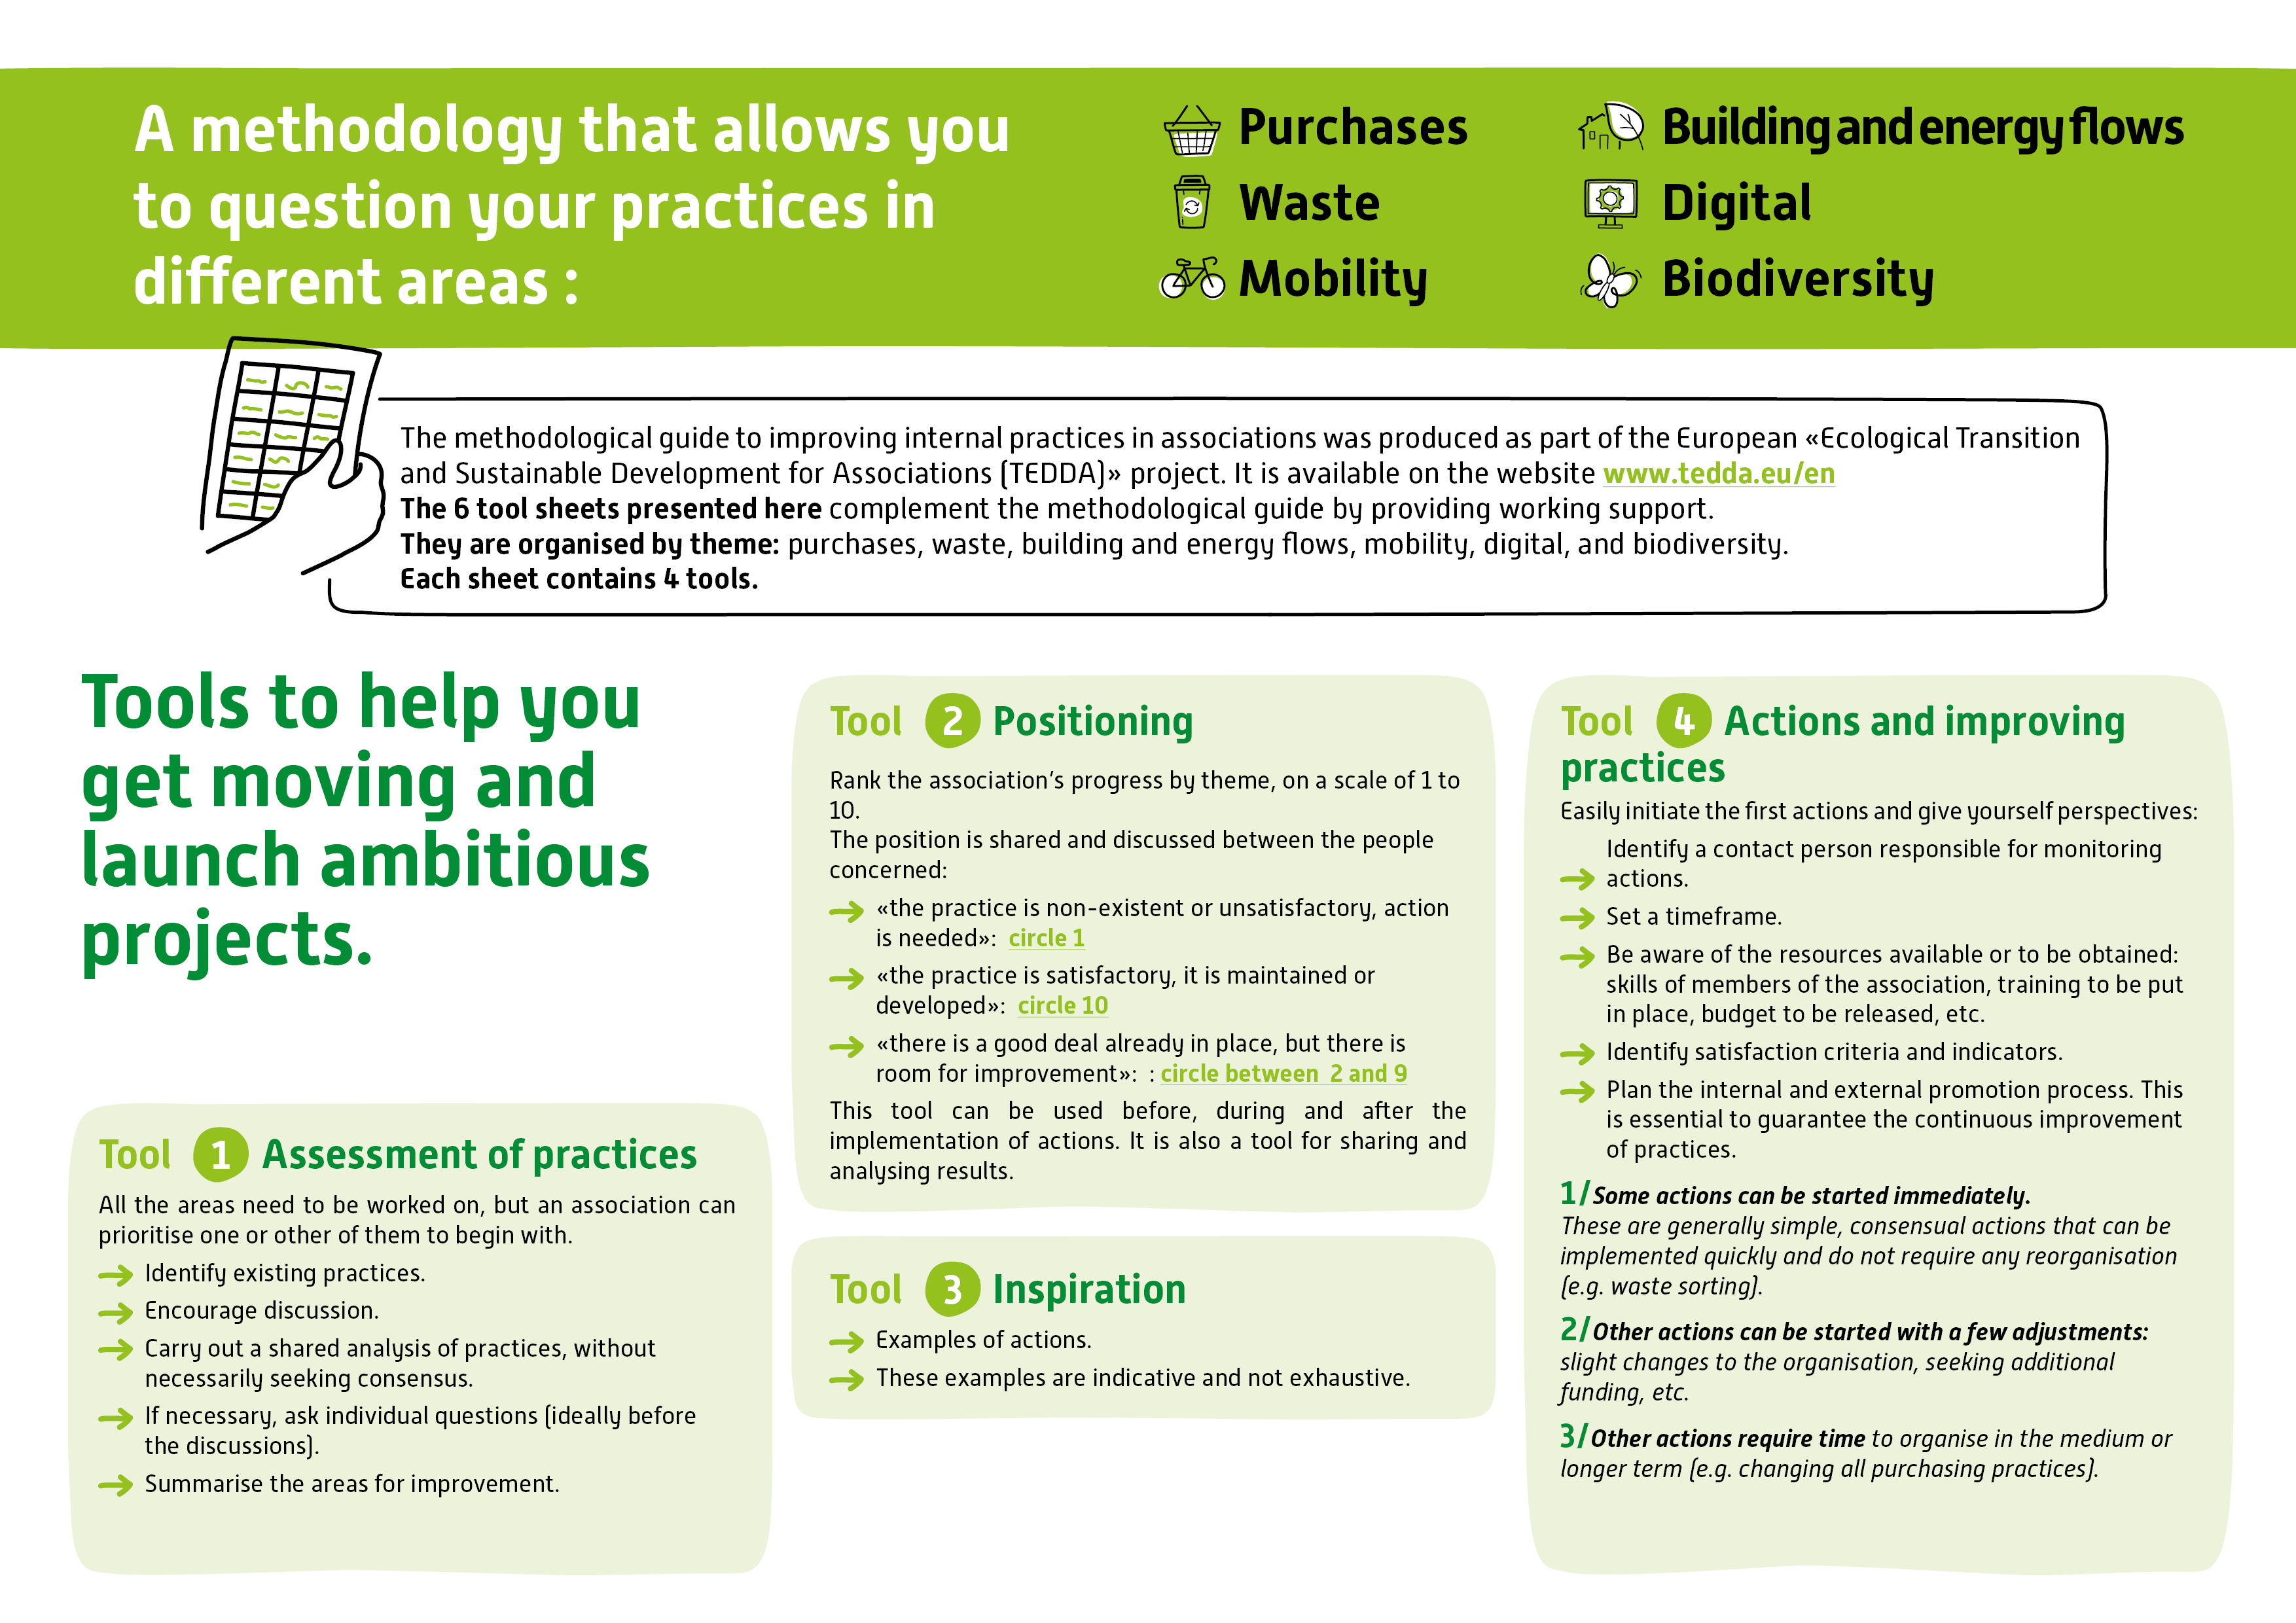
Sections to be questioned |  | Our practices | Summary of areas for improvement
M1 | Practices by means of transport  For each employee, volunteer and director, by type of journey (at least business and home-work journeys), identify:  - Which means of transport are used to get around?  - How many kilometres are covered by each mode of transport (car, bike, train, walking, etc.)?  - How much use is made of public transport, active soft mobility (walking, cycling, scootering, etc.) and private cars?  - Are there any car-pooling or car-sharing schemes?  - Is there a fully equipped kitchen so that you don't have to go out for lunch?  - List, without judgement, the reasons for these choices rather than others, as well as any obstacles or constraints to change (e.g. dropping children off at school).  - By which means of transport do your customers and partners travel to visit you?
M2 | Accessibility of the activity site(s)  Public transport  - Is your activity site accessible by public transport (train, bus, metro, tram, etc.)? If so, list all the options.  - Is the public transport service convenient for your personal and professional needs (frequency, range of times, etc.)?  Active soft mobility  - Bicycles and scooters: Is there a self-service bicycle hire scheme near your site? Are there suitable cycle paths to get to work? Is there a secure, suitable garage for bicycles? Accessible electric recharging points? Are there showers on your premises? Is there a place to charge your bike/electric scooter?  - Pedestrian access: Are there any facilities (pavements, for example, or pleasant paths) for getting to the site on foot?  More virtuous individual mobility:  - Is it possible to carpool within your site or with other neighbouring structures? Is there a designated car-pooling area?  - Is it possible to charge an electric car near the site?
M3 | Organisation of the association's activities:  - For what types of activity do members of the association (employees, volunteers, administrators) travel? E.g.: meetings with partners, participation in an event, training, lunch breaks, etc.  - For each of the activities identified:  - How often and how often do they recur?  - How many kilometres are covered?  - How many participants?  - Do we need to transport any equipment?  - Would it be easier for the partner to get to your site than yours?  - Are there any other constraints (rural environment, lack of public transport, travelling at night, etc.)?  - Is it possible to reduce certain journeys?  - Is it possible to telework? If so, how often? How many days a week? Does this apply to all staff?
M4 | Supportive measures  Have you put in place support measures for volunteers and employees to encourage them to make greater use of soft modes of transport?  - Financial assistance: do you pay more than the legal minimum for public transport season tickets? Is the use of bicycles facilitated by the mileage reimbursement scheme?  - Car-sharing subscription for the structure.  - Support for training, assistance with new practices (e.g. learning to cycle).  - Mobility charter.

« practice is non-existent or unsatisfactory, action is needed » : circle 1
« the practice is satisfactory, it is maintained or developed » : circle 10
« there is a good deal already in place, but there is room for improvement » : circle 2 to 10
M1
Practices
by means of transport
⬇

Drag these 3 points onto the graph
to the desired number

  M4 ➔ ⬅ M2
Supportive measures Accessibility of the
activity site

⬆
M3
Organising the association’s activities
Examples of action to take |  | Examples of indicators
M1 | Practices by means of transport  - Listen to the difficulties and obstacles encountered by everyone in changing their mode of transport.  - Raise awareness using comparative tools, such as a carbon calculator for each type of transport: https://datagir.ademe.fr/apps/mon-impact-transport.  - Organise festive, fun events to try out new practices (e.g. mobility challenge).  Encourage the use of public transport  - Make an inventory of the services on offer and their timetables: display them on the premises, include them in emails inviting people to meetings and in communication brochures.  - Increase financial support for the various forms of sustainable mobility and find out about assistance available locally or at national level.  - Offer equipment (computers, etc.) that is light and easy to transport by public transport.  Encourage the use of active modes of transport (walking, cycling, scootering, etc.)  - Raise awareness of the health benefits of active mobility.  - Make bicycles and scooters available for meetings close to the site.  - Provide facilities for showering, changing, safe bike parking, recharging electric scooters, repairing punctured bikes, etc.  - Helping to set up training and support programmes to help people get to grips with their bikes: getting back in the saddle, safe handling, information on safe routes, help with maintenance and self-repair, etc.  Limiting the use of private cars  - Subscribe to a car-sharing service.  - Helping with car-pooling: identifying a dedicated location, discussion with other structures on the site, financial contributions, cooperative car-pooling platforms, etc.  - Help with the installation of electric recharging points.  - If necessary, reduce the company's fleet of cars and move towards hybrid, electric or less polluting vehicles. | - Number of people involved in the process.  - Proportion of people who have changed their practices.  - Change in practices of customers and volunteers.  - Details of changes in practices and carbon impacts avoided.  - Impact of changes in mobility on the association's ability to fulfil its missions and carry out its activities.  - People's satisfaction with the changes made: impact on quality of life at work, personal and professional life balance.
M2 | Accessibility of the activity site(s)  - Publish on the website and systematically include in invitations the types of access available using sustainable mobility (train, metro, bicycle terminal, etc.).  - Make a list of the services on offer and the timetables: display them in the premises, include them in meeting invitations and in communication brochures.  - During activities, add a section on "distance travelled to get here" and "mode of transport in order to identify the levers for action" to the attendance sheets.  - Be a driving force for change in your local authority:  - Present the organisation's actions and the obstacles linked to urban development and the sustainable mobility services on offer.  - Discuss public transport services: frequencies, stops, self-service bicycle stations, car-sharing....  - Suggest the installation of urban facilities (e.g. cycle racks, bus stops, pavements).  - Participate in initiatives such as " civic budgeting ", " participatory budgeting " and/or in conjunction with groups of residents or local economic stakeholders. | - Changes in the sector.  - Changes in customer and volunteer practices.  - Details of changes in practices and carbon impacts avoided.
M3 | Organising the association's activities:  - Avoid certain trips.  - Test teleworking on one or more days a week.  - Facilitate teleworking adapted to the needs of the business and the employees, with a charter that regulates, frames and authorises the practice.  - Fund access to co-working spaces when the workplace is far from home.  - Organise video-conferencing for certain meetings, in agreement with the participants and avoiding the practice becoming systematic in order to maintain a convivial atmosphere.  - Facilitate arrivals and departures according to public transport timetables and/or to avoid excessive traffic. | - Trips avoided.  - Number of people trying out teleworking.  - Investment in videoconferencing equipment.
M4 | Supportive measures  - Provide forums for discussion and assessment of mobility at least once a year :  . Discuss these issues with volunteers.  . Put this issue on the agenda of a board meeting.  - Vote a minimum budget to support sustainable mobility.  - Propose awareness-raising and training initiatives in conjunction with associations.  - Increase financial support for the various forms of sustainable mobility and find out about local and national funding available.  - Provide information on the various alternatives available.  - Set up a sustainable mobility plan that lists and shares the tools and practices recommended. | - Existence of time for discussion and assessment.  - Implementation of a mobility charter or travel plan.  - Existence of a mobility officer within the organisation.  - Percentage of budget allocated to sustainable mobility.  - Number of training courses offered.  - Number of awareness-raising initiatives.

Choice of actions |  | Contact and people involved | Timing  - in progress  - this year  - throughout 3 years | Resources to obtain  These may be resources available within the association or within the community (partners, institutions, etc.), or resources that need to be sought out, for example:  - human skills and resources: volunteers, salaried users or other people in the community, etc.  - financial resources (internal, subsidies and dedicated support)  - organisational resources  - technical resources  - support | Criteria of success and indicators  What are the elements that will enable you to be satisfied with the actions taken and the path followed to achieve them?  You can use qualitative and quantitative indicators | Internal and external promotion  How do you plan to communicate on your actions?  Internally, to share progress and show what's been achieved, and to go further.  Externally, to promote what you are doing
M1
Practices by means of transport
M2
Accessibility of the activity site(s)
M3
Organising the association's activities:
M4
Supportive measures

